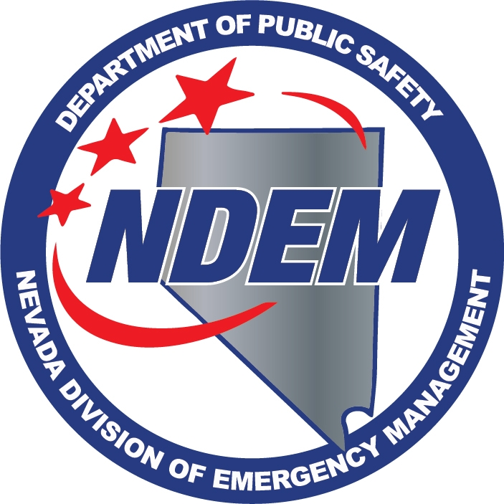 DEPT. OF PUBLIC SAFETY
DIVISION OF EMERGENCY MANAGEMENT
WORKSHOP TO SOLICIT COMMENTS ON REGULATORY ADOPTION
MINUTES

Attendance | Date | March 7, 2016
 | Time | 1:00 PM
 | Location | Legislative Counsel Bureau  Legislative Building, Room 3138  401 S. Carson St.  Carson City, NV 89711
 | Method | Record/Live Stream  Legislative Counsel Bureau  Grant Sawyer State Bldg. Room 4401  555 East Washington Ave.  Las Vegas, NV 89101
 | Recorder | Chris Molnar
 | Present
Caleb Cage | X | Chief/Nevada Division of Emergency Management/Homeland Security Advisor
Samantha Ladich | X | Senior Deputy Attorney General

1. Call to Order – Caleb Cage
Caleb Cage, Chief of the Nevada Division of Emergency Management (NDEM), called the workshop to order at 1:00pm. He introduced Samantha Ladich, Senior Deputy Attorney General.

2. Public Comment

Chief Cage called for public comment, and there was no public comment.

3. Workshop – Chief Cage announced the NDEM is seeking comments on regulations related to the information that must be included in a report of damages when seeking a grant or loan from the Disaster Relief Account (DRA), as referenced in Chapter 353 of the Nevada Revised Statutes. He continued with an explanation of NRS 353.2735, which creates a Disaster Relief Account (DRA) in the state’s general fund in order to provide grants and loans to state agencies and local governments. He continued by reading paragraph 4, of NRS 353.2753, which states “the Division shall prescribe by regulation the information that must be included in a report of damages, including, without limitation, a description of the damage caused by the event, an estimate of the costs to repair such damage and a specification of whether the purpose of the project is for repair or replacement, emergency response or mitigation.” He explained though there are internal procedures for request to the DRA, there are no regulations established for the DRA, as required by the NRS. He said that the division is providing draft regulations for the DRA, with input from the public. Per NRS 353.2753, Chief Cage proceeded to explain the proposed changes to the regulation. He started with Section I, Chapter 353, of the NAC:

Pursuant to NRS 353.2753, the Division proposes the following regulation:

Section 1: Chapter 353 of the NAC is hereby amended by adding thereto a new section to read as follows:

- The Division shall conduct an assessment upon the request of a local government to determine whether the events constitute a disaster and to assess damages.

- The Division shall draft a report of damages, which shall include the following information:

  - A description of the event resulting in damages, including, but not limited to:
    - Location and Counties affected,
    - Resources requested and utilized, and
    - Declarations requested and signed.

  - Estimated damage totals.

  - A description of the damages to public infrastructure, including information related to:
    - Debris removal,
    - Emergency protection measures,
    - Roads and bridges,
    - Water control facilities,
    - Public buildings and equipment,
    - Utilities, and
    - Recreation.

  - A description of the damages to affected homes and businesses.

  - A description of other assistance requested and received.

  - The purpose of proposed project, including, but not limited to:
    - Repair,
    - Replacement,
    - Emergency Response, and
    - Mitigation.
Chief Cage said that concluded the draft proposed regulation developed by the NDEM, and asked if anybody had joined the meeting in the South. Seeing none, he asked for comments or recommendations for the proposed regulation by the NDEM. There were no comments or recommendations.
4. Public Comment
Chief Cage called for public comment. There was no public comment.
5. Adjournment
Chief Cage explained the minutes will be available to the public and members of the community could submit written recommendations following the meeting. Without further participation from the public, Chief Cage adjourned the meeting.

